**Assignment Day-6**

Ans.1

Created the malware using msfvenom and transferred it over the victim machine. Then handled the victim machine using Metasploit.

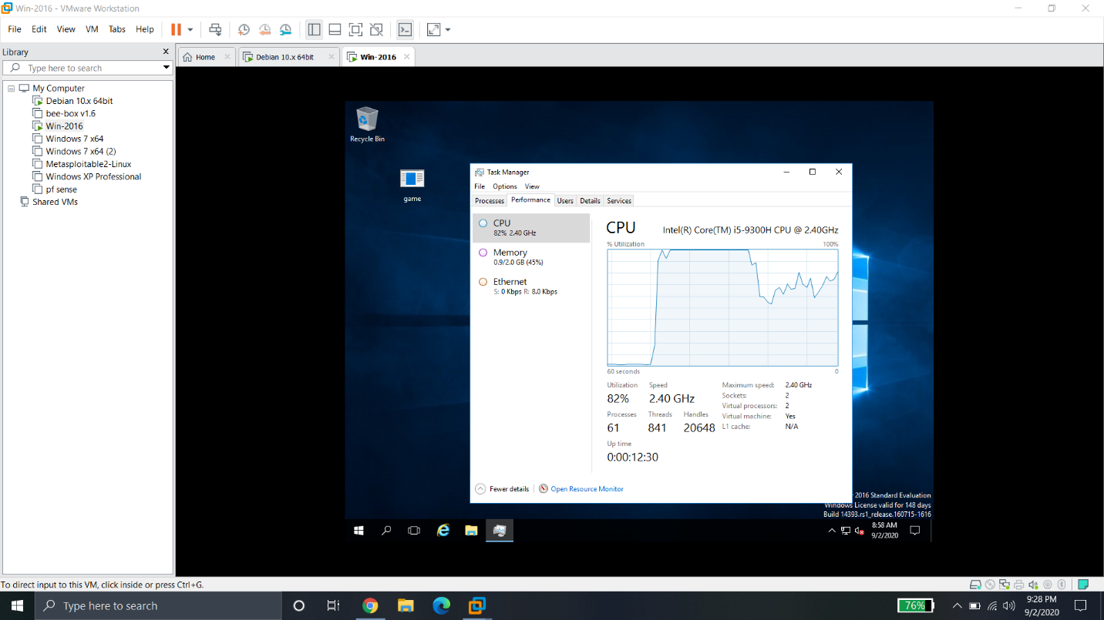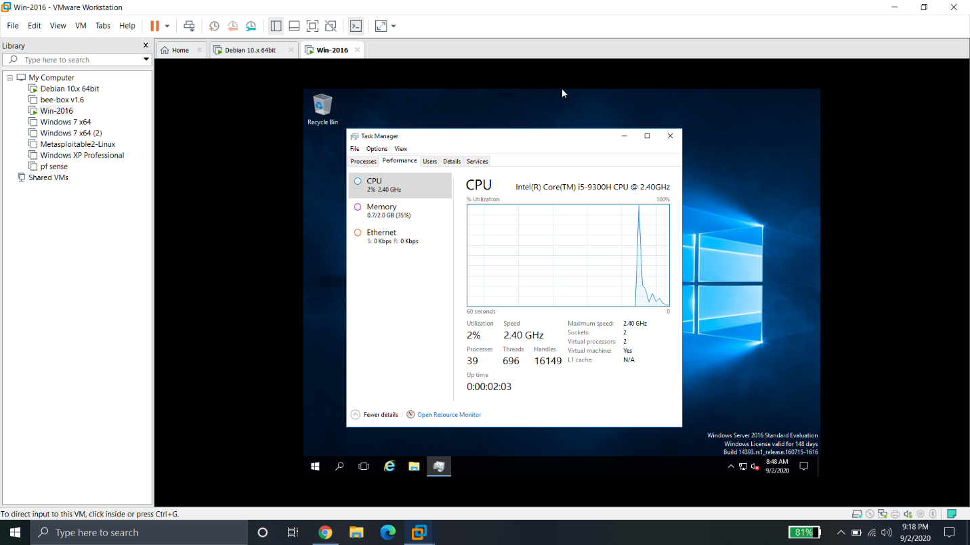

Ans.2

Enabled the ftp connection on machine and then gain access to ftp server on main machine.

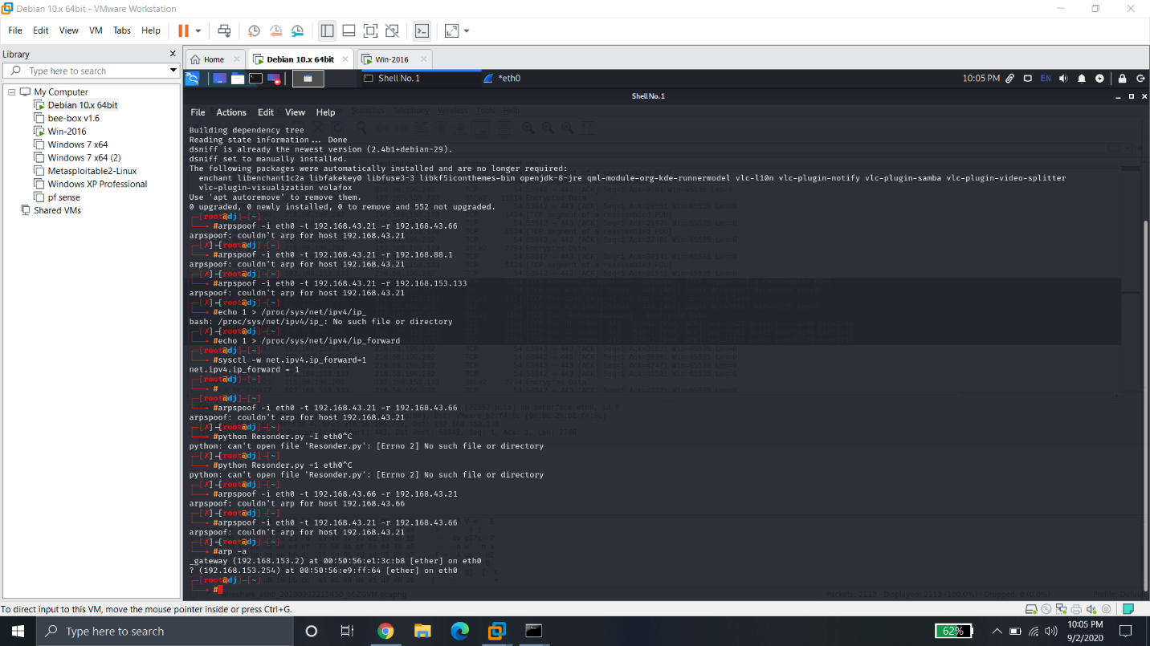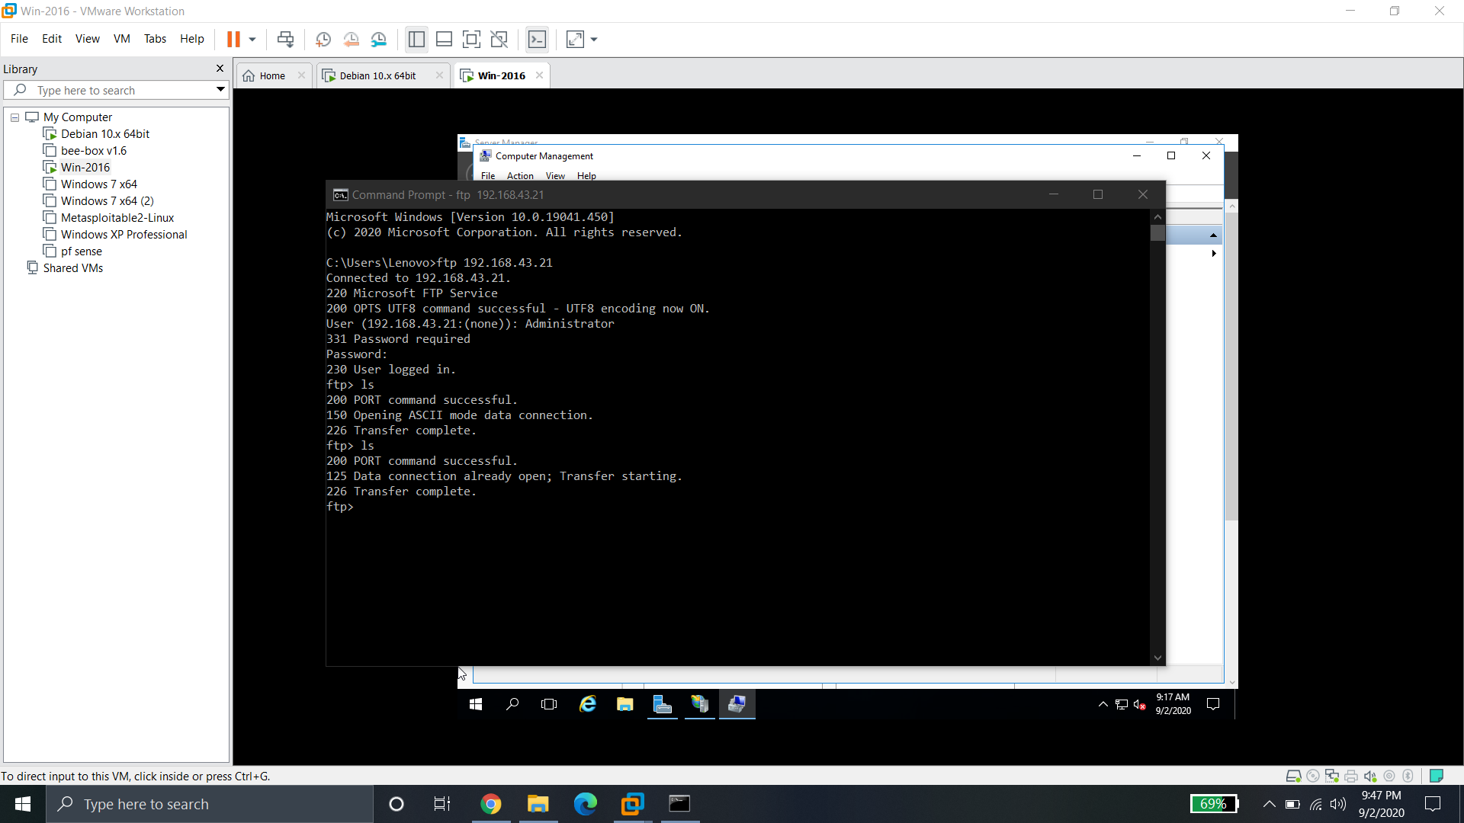

There was some problem while doing arpspoof. I was unable to resolve it.